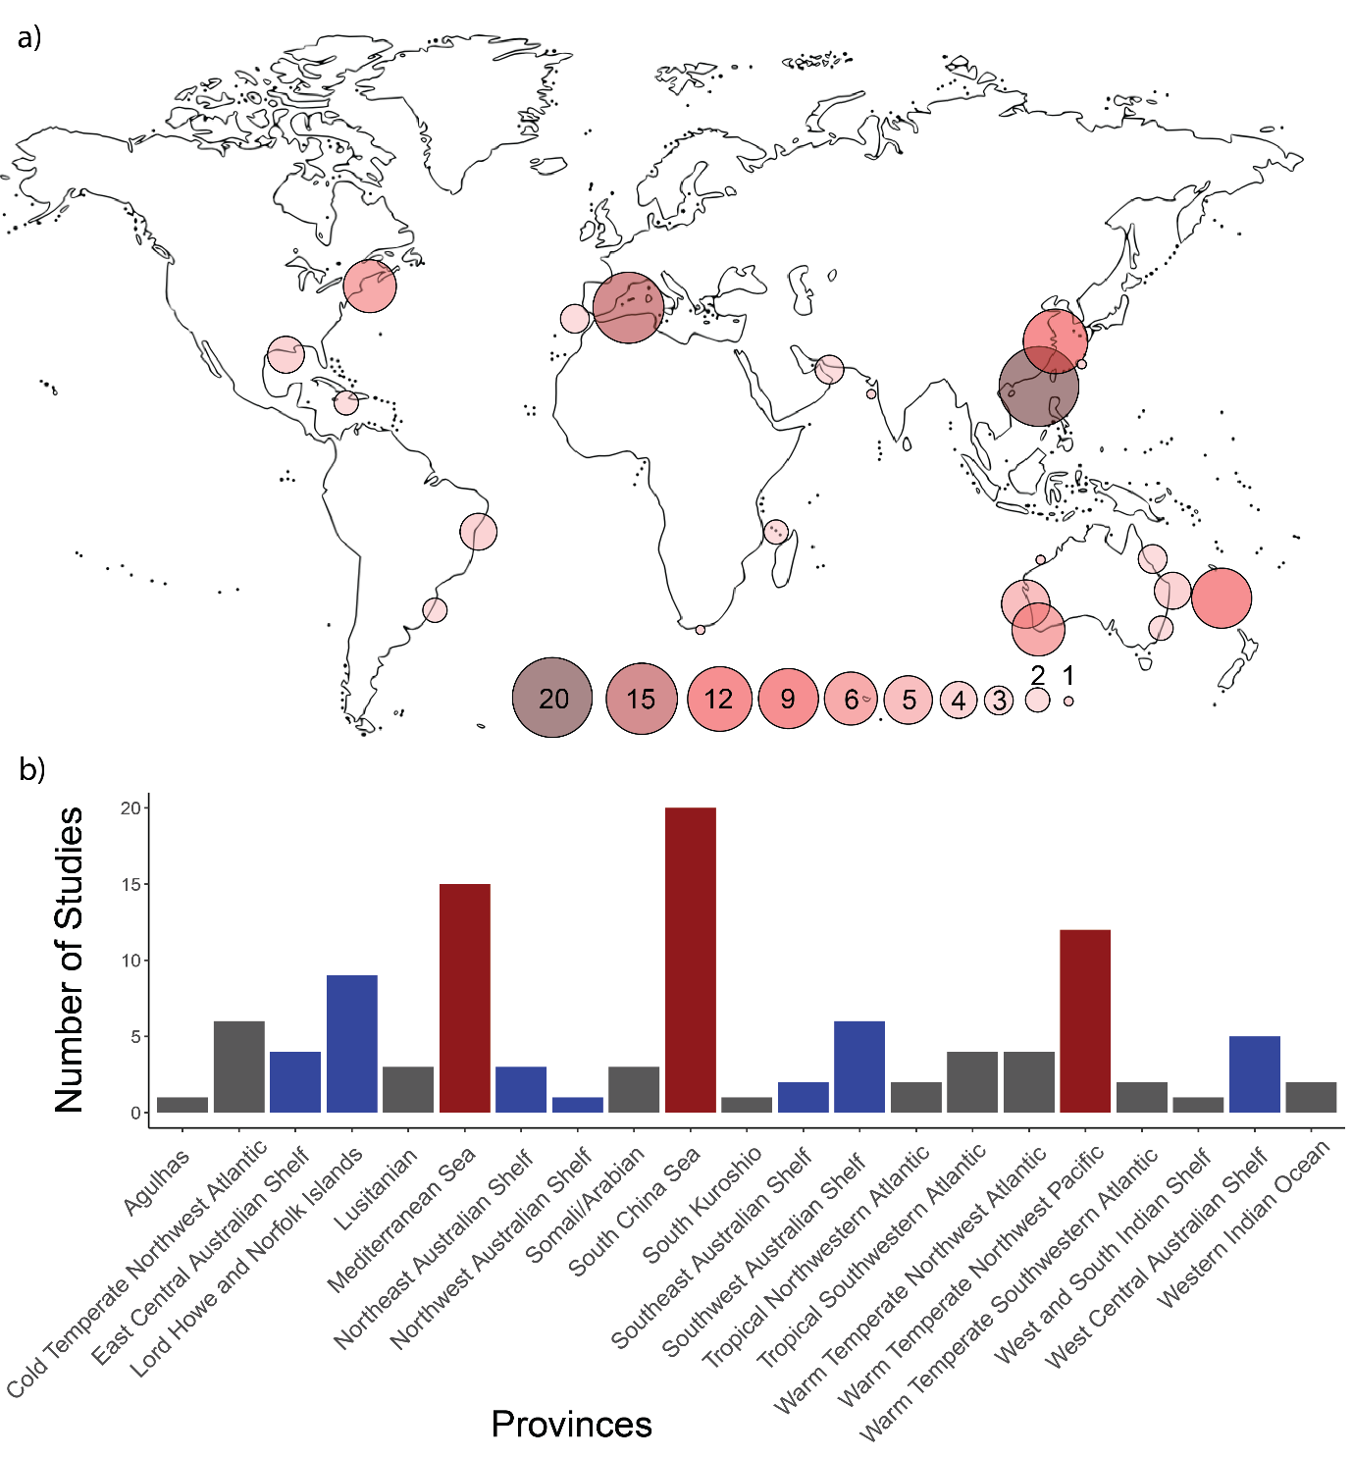

Figure 8 a) World map showing the knowledge cluster by ecoregion. b) Number of studies by provinces, showing top 3 provinces (Red) and provinces in Australia (Blue).